Title of the Dissertation / Internship
PAMCA698J - Dissertation-1/ Internship-1

Submitted in partial fulfillment of the requirements for the degree of

Master of Computer Applications
in
Department of Computer Applications

by

Student NAME
REGISTER NUMBER

Under the guidance of

Prof. / Dr.

School of Computer Science Engineering and Information Systems
VIT, Vellore



November, 2026
Title of the Dissertation / Internship
PAMCA698J - Dissertation-1/ Internship-1

Submitted in partial fulfillment of the requirements for the degree of

Master of Computer Applications
in
Department of Computer Applications

by

Student NAME
REGISTER NUMBER

Under the guidance of

Prof. / Dr.

School of Computer Science Engineering and Information Systems
VIT, Vellore

November, 2026
DECLARATION

I hereby declare that the PAMCA698J - <Dissertation-1/ Internship-1> entitled “Dissertation-1 / Internship-1title" submitted by me, for the award of the degree of Master of Computer Applications in Department of Computer Applications, School of Computer Science Engineering and Information Systems to VIT is a record of bonafide work carried out by me under the supervision of <Off – Campus Internship Guide Name>, < Designation>, <Company Name> and <VIT – Faculty Guide Name, Designation, SCORE, VIT, Vellore>.
I further declare that the work reported in this dissertation / internship has not been submitted and will not be submitted, either in part or in full, for the award of any other degree or diploma in this institute or any other institute or university.

Place: Vellore
Date:

Signature of the Candidate

CERTIFICATE
This is to certify that the PAMCA698J - <Dissertation-1/ Internship-1> entitled “Dissertation-1 / Internship-1title” submitted by Student Name & Reg. No, SCORE, VIT, for the award of the degree of Master of Computer Applications in Department of Computer Applications, is a record of bonafide work carried out by him / her under my supervision during the period, 06. 07. 2026 to 03.11.2026, as per the VIT code of academic and research ethics.
The contents of this report have not been submitted and will not be submitted either in part or in full, for the award of any other degree or diploma in this institute or any other institute or university. The dissertation / internship fulfills the requirements and regulations of the University and in my opinion meets the necessary standards for submission.

Place: Vellore
Date:

Signature of the Company Guide
<For off-campus internship students only>

Signature of the VIT-SCORE - Guide

Internal Examiner External Examiner

Head of the Department
Department of Computer Applications

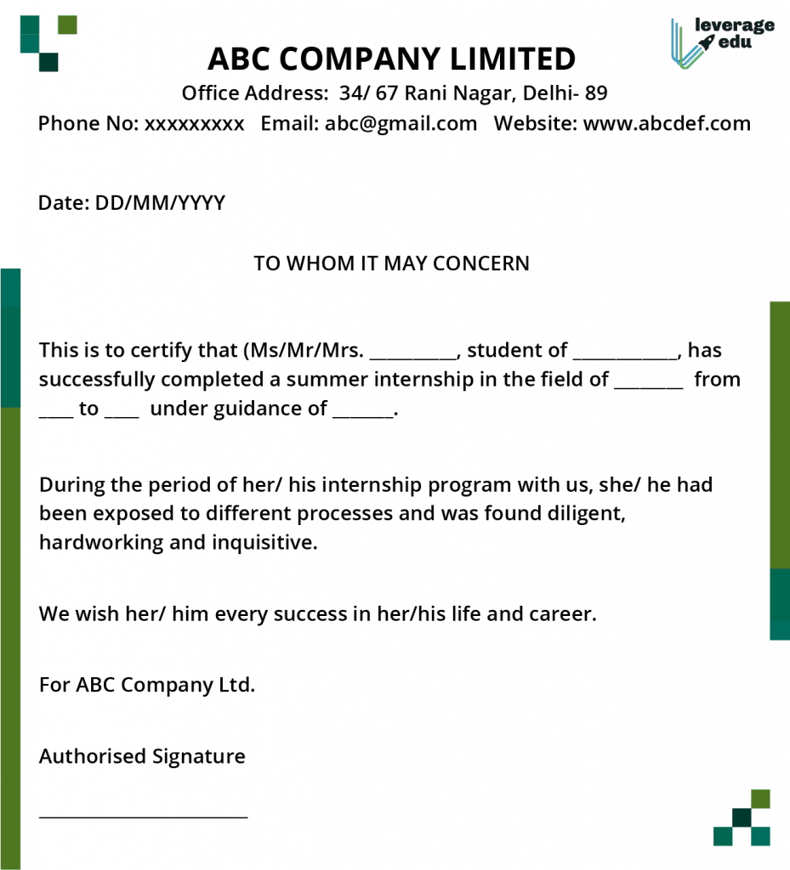
Off-Campus Internship Certificate
<For off-campus internship students only>

ACKNOWLEDGEMENT

It is my pleasure to express with a deep sense of gratitude to my Dissertation-1 / Internship-1 guide <Dr. or Prof. Guide Name, Designation>, School of Computer Science Engineering and Information Systems, Vellore Institute of Technology, Vellore for his/her constant guidance, continual encouragement, in my endeavor. My association with him/her is not confined to academics only, but it is a great opportunity on my part to work with an intellectual and an expert in the field of < Domain or dissertation / internship area >.

"I would like to express my heartfelt gratitude to Honorable Chancellor Dr. G Viswanathan; respected Vice Presidents Dr. Sankar Viswanathan, Dr. Sekar Viswanathan, Vice Chancellor Dr. V. S. Kanchana Bhaaskaran; Pro-Vice Chancellor Dr. Partha Sharathi Mallick; and Registrar Dr. Jayabarathi T.

My whole-hearted thanks to Dean Dr. Daphne Lopez, School of Computer Science Engineering and Information Systems, Head, Department of Computer Applications Dr. Senthilkumar N, MCA Project Coordinator Dr. Krishnamoorthy N, SCORE School Project Coordinator Dr. Karthikeyan P, all faculty, staff and members working as limbs of our university for their continuous guidance throughout my course of study in unlimited ways.

It is indeed a pleasure to thank my parents and friends who persuaded and encouraged me to take up and complete my dissertation/ Internship successfully. Last, but not least, I express my gratitude and appreciation to all those who have helped me directly or indirectly towards the successful completion of the dissertation/ Internship.

Place: Vellore
Date: <Student Name>

Executive Summary

Summary of the dissertation / internship for one page and not exceeding 200 words

CONTENTS Page
No.

Acknowledgement i
Executive Summary ii
Table of Contents iii
List of Figures ix
List of Tables xiv
Abbreviations xvi
Symbols and Notations xix
- INTRODUCTION 1
  - Objective 1
  - Motivation 2
  - Background 3
- DISSERTATION / INTERNSHIP DESCRIPTION AND GOALS 3
- TECHNICAL SPECIFICATION 3
- DESIGN APPROACH AND DETAILS (as applicable) .

  - Design Approach / Materials & Methods .
  - Codes and Standards .
  - Constraints, Alternatives and Tradeoffs .

- SCHEDULE, TASKS AND MILESTONES .

- DISSERTATION / INTERNSHIP DEMONSTRATION .

- COST ANALYSIS / RESULT & DISCUSSION (as applicable) .

8 | SUMMARY | .
9 | REFERENCES | .
 | APPENDIX A | .

Note: from Chapter 4 to Chapter 7 according to your Dissertation / Internship, you are allowed to modify or to add the required chapters. Please discuss with your guide and add/modify the chapters accordingly.

List of Figures

Figure No. |  | Title | Page No.
2.1 | Figure caption |  | 13
2.2 | Figure caption |  | 15

(In the chapters, figure caption should come below the figure and table caption should come above the table. Figure and table captions should be of font size 10.)

List of Tables

Table No. Title Page No.
2.1 Table caption 28

List of Abbreviations

3GPP Third Generation Partnership Project
2G Second Generation
3G Third Generation
4G Fourth Generation
AWGN Additive White Gaussian Noise

Symbols and Notations

δf CFO
ε NCFO

CHAPTER 1

INTRODUCTION

Artificial Intelligence (AI) refers to the development of computer systems that can perform tasks typically requiring human intelligence. These tasks range from recognizing speech, understanding natural language, making decisions, solving problems, to even learning from experience. AI encompasses a broad field of study, including machine learning, neural networks, robotics, natural language processing, and computer vision. By mimicking cognitive functions, AI aims to create systems capable of adapting to new information, making predictions, and optimizing processes.

SAMPLE PAGE

As technology continues to evolve, AI has moved from theoretical concepts to practical applications that are transforming industries. From virtual assistants like Siri and Alexa to self-driving cars, healthcare diagnostics, and personalized recommendations, AI is reshaping how we live, work, and interact with the world around us. Understanding AI is crucial as it increasingly influences our daily lives, presents ethical challenges, and offers unprecedented opportunities for innovation and efficiency.

Objective

The primary objective of this AI project is to develop a [specific AI system/tool/application] that utilizes machine learning and data analysis techniques to [solve a particular problem or enhance a process]. The project aims to…

1.2 Motivation

An AI-based Traffic Management System aims to optimize the flow of vehicles in urban areas by leveraging machine learning algorithms and real-time data. Utilizing inputs from traffic cameras, sensors, and GPS data, the AI can predict traffic congestion, adjust traffic light timings dynamically, and suggest optimal routes for drivers. This reduces travel time, minimizes fuel consumption, and decreases carbon emissions.

By analyzing historical traffic patterns and integrating with public transportation systems, the AI can provide more accurate traffic forecasts and support city planners in making data-driven infrastructure decisions,

Page Specification:
Left Margin: 1.5 inch
Right Margin: 1 inch
Top Margin: 1 inch
Bottom Margin: 1 inch
Font & Size:
Entire Dissertation - Font Name: Times New Roman
Font size: 12
Chapter Heading Font size: 14 and CAPS, BOLD
Sub Heading Font size: 12 and No CAPS

Paragraph:
Paragraph Alignment: Justify

Paragraph line Space: 1.5 line space

Paragraph: In every chapter’s first paragraph, first line without 1 tab space and continue, in next paragraph with 1 tab space till the end of the chapter.
*For reference check Chapter 1 formatting in this document

Bullet points: do not use bullet numbering, instead use bullet image, select
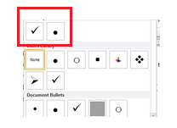

* for types, classifications , you can use bullet numbering (where it is required to mention in numbers)

Page Numbers:
- Use roman letters page numbering from cover page to symbols and Notations chapter.
- For Cover page do not make the page number visible.
- From page number ii , should be visible before the chapter 1
- Use numeric page numbers (1, 2,3,..) from chapter 1. Introduction till References sections
- For Appendices, No page numbers required
- Total Number of pages required: 70 and above (from chapter 1 to reference section)
- In Appendices: you can add any other sample codes, images, manuals, Readme.txt etc.,)
Figures:
- Centre the figure, Make it clear and visible, for better view go for portrait format. If the figure is huge in size then go for landscape format for image.
- In the chapters, figure caption should come below the figure.
- Figure Caption should be in the Title Case, Times New Roman, 10 pt, and it should be of the Format: Fig. Chapter Number.Figure Number Figure Caption
- In below example Figure , Second chapter. 4th image in the second chapter, title of the figure.

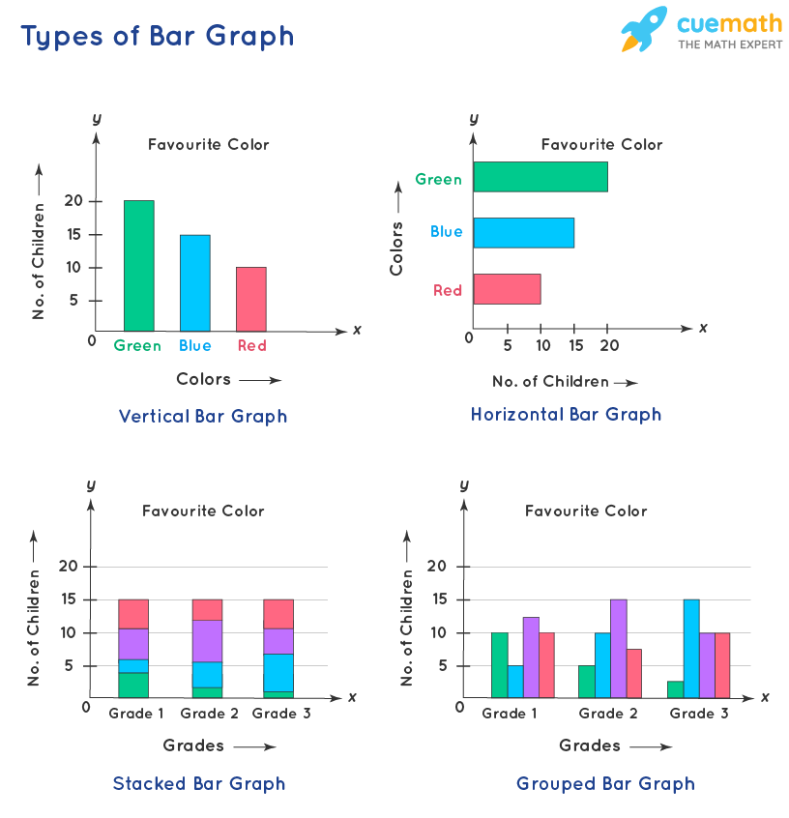
Fig. 2.4 Sample Bar Graph
Tables:
- For Tables: Title of the table should come in the top of the table as follows
- All the table caption should be in the Title case , Times New Roman, 10Point and it should be of the format: Table.Chapter Number.Table number Table Caption
SAMPLE TABLE
Table 6.1 MI and Deep Learning
Artificial Intelligence | Machine Learning | Deep Learning
AI stands for Artificial Intelligence, and is basically the study/process which enables machines to mimic human behaviour through particular algorithm. | ML stands for Machine Learning, and is the study that uses statistical methods enabling machines to improve with experience. | DL stands for Deep Learning, and is the study that makes use of Neural Networks(similar to neurons present in human brain) to imitate functionality just like a human brain.
AI is the broader family consisting of ML and DL as it’s components. | ML is the subset of AI. | DL is the subset of ML.
AI is a computer algorithm which exhibits intelligence through decision making. | ML is an AI algorithm which allows system to learn from data. | DL is a ML algorithm that uses deep(more than one layer) neural networks to analyze data and provide output accordingly.

Equations:
Every equation should be used by relevant tools or symbols in the word editor.
Every equation should be cited as Eqn. 5.2 (Equation. fifth chapter.2 equation)
A²+B²=C (5.2)
When you cite the above equation should cite as follows;
In the Eqn. 5.2 the variable A denotes the parameter of..

CHAPTER 8
SUMMARY
A brief summary of the dissertation / internship findings, expected results. Recommendations

CHAPTER 9

REFERENCES
SAMPLE REFERENCES
- Domenico Bloisi, Luca Iocchi, Michele Fiorini, Giovanni Graziano, “Automatic Maritime Surveillance with Visual Target Detection”, International Defense and Homeland Security Simulation Workshop (DHSS), September 2011.
- Domenico Bloisi, Luca Iocchi, Michele Fiorini, Giovanni Graziano, “Camera Based Target Recognition for Maritime Awareness”, Information Fusion (FUSION), 15th International Conference, July 2012.
- Rodrigo Da Silva Moreira, Nelson Francisco Favilla Ebecken, Alexandre Soares Alves, Frédéric Livernet4, Aline Campillo-Navetti, “A Survey on Video Detection and Tracking of Maritime Vessels”, IJRRAS 20, July 2014.
- Sergiy Fefilatyev, “Algorithms for Visual Maritime Surveillance with Rapidly Moving Camera”, Doctoral dissertation, University of South Florida, 2012.
Websites
[5] Digi-key Corporation. http://www.digikey.com/
Data Sets
[6] Alldatasheet. http://www.alldatasheet.com/

Use APA Format for citation and reference section

Basic format to reference journal articles

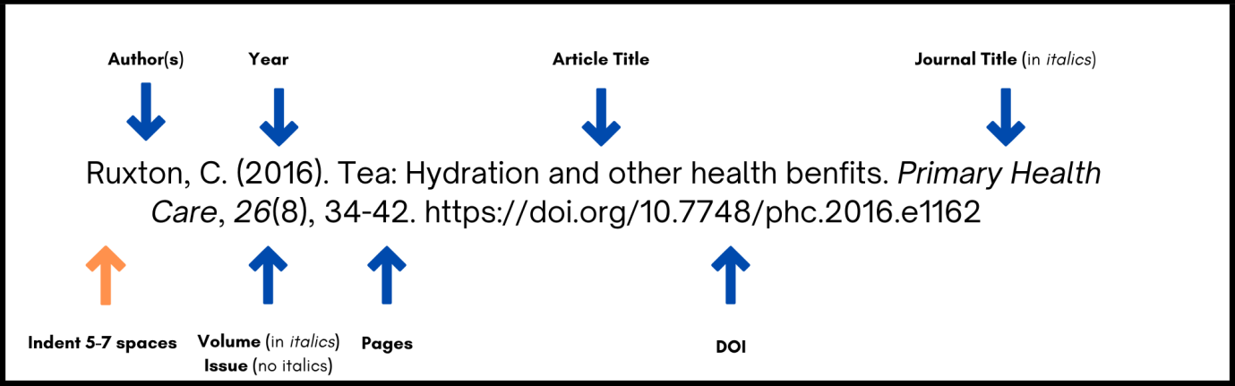
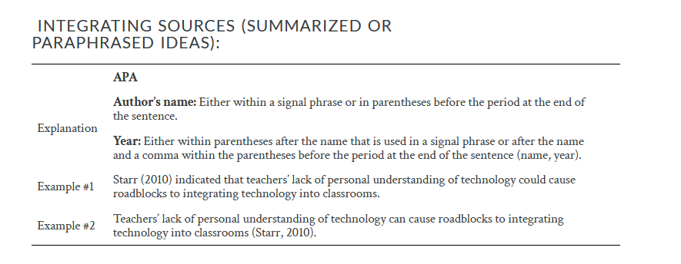
Single Author format for APA Citation
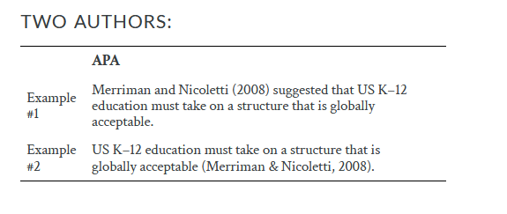
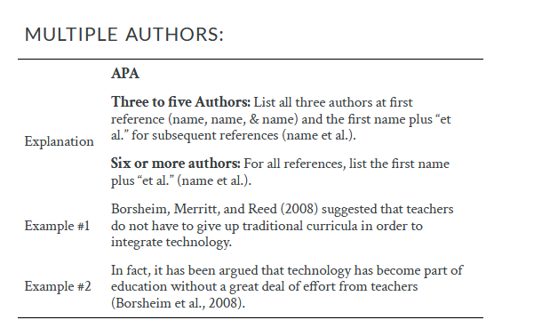
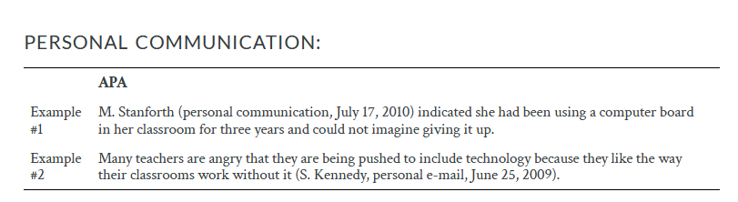

APPENDIX A
- Page numbers are not required from Appendix section
- You can keep additional sample codes and sample screen shots of your Dissertation / Internship in appendix A; and inside the dissertation, wherever required, the codes, algorithms, images should be kept. In Appendix whatever you keep are additional only
- Don’t keep the entire codes in the documents; use sample codes only, whichever is important.
- Screen shots of the Dissertation / Internship ; use sample images only, whichever is important

Cover Page - Format
